API Security Risk Analysis Report
Task 3 | Cyber Security Track (CS)
Future Interns Internship Program

Prepared By | Shabbir Ahmed
Internship Track | Cyber Security (CS)
Task Number | Task 3
Organization | Future Interns
Date | May 2026
APIs Tested | JSONPlaceholder, ReqRes
Tools Used | Postman, Browser DevTools
Total Findings | 6 (High: 3, Medium: 3)

1. Executive Summary
This report is the output of Task 3 from my Cyber Security internship at Future Interns. The task involved performing a manual API security analysis on two publicly available REST APIs — JSONPlaceholder (jsonplaceholder.typicode.com) and ReqRes (reqres.in).
I tested these APIs using Postman from a black-box perspective, meaning I acted as an outside attacker with no internal access or source code. The idea was to find common security weaknesses that developers sometimes miss when building APIs — things like missing authentication, too much data being shared, no limits on how many requests you can make, and so on.
In total I found 6 vulnerabilities — 3 rated High severity and 3 rated Medium severity. Each finding is documented with a description of what I tested, what happened, what the business risk is, and how a developer could fix it.
2. Scope & Methodology
APIs Tested: JSONPlaceholder (https://jsonplaceholder.typicode.com) and ReqRes (https://reqres.in)
Tools: Postman for sending API requests, Browser DevTools for inspecting headers
Approach: Black-box testing — no credentials, no source code, external attacker perspective
I tested each API by sending GET and POST requests manually through Postman, varying the endpoints and parameters to see what information was returned and whether any security controls were in place. Screenshots were taken of every significant response.
3. Vulnerability Findings
Finding 1 — No Authentication Required [HIGH]
Endpoint | GET https://jsonplaceholder.typicode.com/users/
What I Did | Sent a basic GET request with no API key, no token, and no login credentials at all.
What Happened | The API returned a complete list of all 10 users — names, emails, phone numbers, home addresses, geo-coordinates, and company info — with a 200 OK response. Nothing was blocked.
Business Impact | In any real application, this would let literally anyone on the internet pull your entire user database without even creating an account. It's one of the most serious API security failures possible.
How to Fix | Add authentication to all user-related endpoints — at minimum require an API key, but ideally use JWT Bearer tokens or OAuth 2.0. Any request without valid credentials should get a 401 Unauthorized.

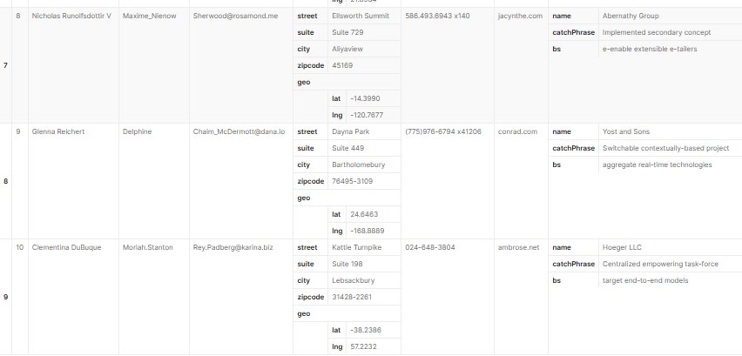
Screenshot 1 — Full user list returned with no authentication (200 OK)
Finding 2 — Excessive Data Exposure [MEDIUM]
Endpoint | GET https://jsonplaceholder.typicode.com/users/1
What I Did | Requested a single user's profile using their ID number in the URL.
What Happened | The response included the user's full address (street, suite, city, zipcode), precise geo-coordinates (lat/lng), phone number, website, and full company details. Way more than a front-end would ever actually need.
Business Impact | Sending extra data increases the risk of a privacy breach. If an attacker can get address and geo-location data from a profile endpoint, they have more than enough to target users. It also makes GDPR compliance harder.
How to Fix | Only return the fields that the specific feature actually needs. Use a DTO (Data Transfer Object) layer to filter the response before it leaves the server. Never expose raw database rows directly through an API.

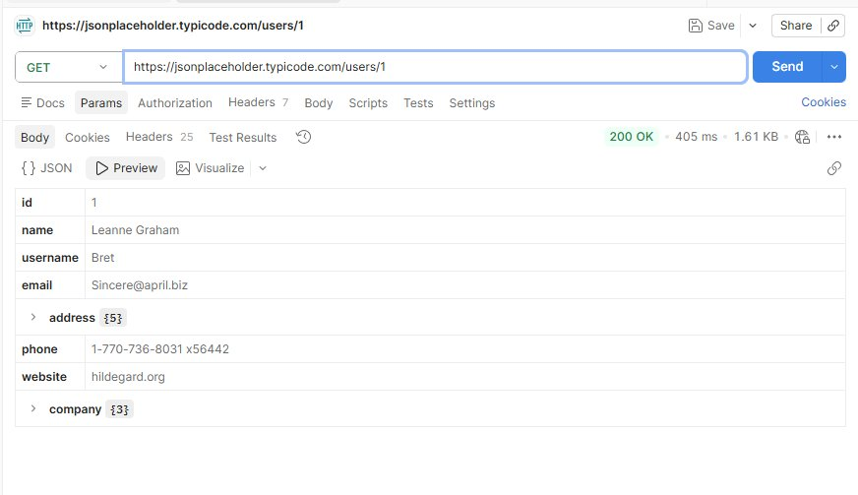
Screenshot 2 — /users/1 exposing full address, geo-coordinates, phone, and company data
Finding 3 — No Rate Limiting [HIGH]
Endpoint | GET https://jsonplaceholder.typicode.com/posts (all endpoints)
What I Did | Sent the same GET /posts request 15+ times rapidly in Postman — no delays, no throttling on my end.
What Happened | Every single request came back 200 OK. The API returned all 100 posts each time with consistent response times around 1 second. There was no block, no warning, no slowdown at any point.
Business Impact | Without rate limiting anyone can scrape your entire database in seconds, run brute force attacks on login endpoints, or simply hammer the server until it goes down (DoS). This is a very common attack vector on APIs.
How to Fix | Set a rate limit per IP — something like 100 requests per minute is a reasonable starting point. Return 429 Too Many Requests with a Retry-After header when someone hits the limit. Consider stricter limits on sensitive endpoints.

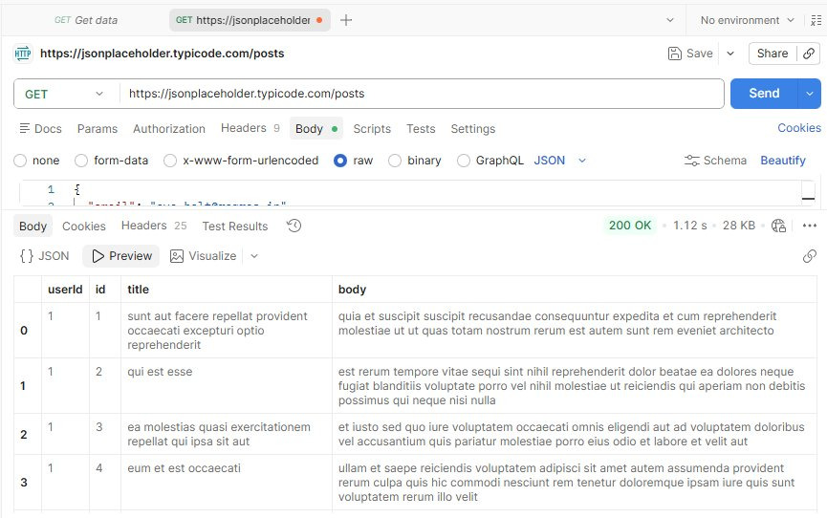
Screenshot 3a — GET /posts returning 200 OK with full results, no throttling
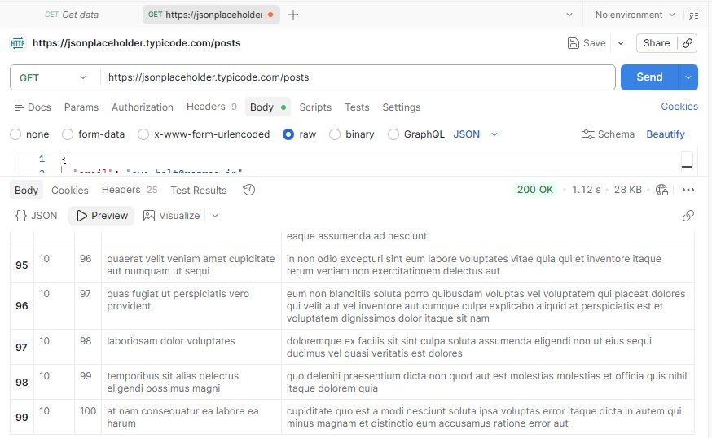
Screenshot 3b — Repeated requests still returning 200 OK all the way through record 100

Finding 4 — IDOR — Insecure Direct Object Reference [MEDIUM]
Endpoint | GET https://jsonplaceholder.typicode.com/users/3 and /users/7
What I Did | Manually changed the user ID in the URL — first to /users/3, then /users/7. No other headers or tokens were changed.
What Happened | I got back completely different users' full profiles each time, all with 200 OK. The API never checked whether I was allowed to view those specific records. I could cycle through every user just by changing one number.
Business Impact | This is OWASP API Security Top 10 — API1 (Broken Object Level Authorization). In a real app, this means any logged-in user could view other users' private data just by modifying the URL. It's one of the most exploited API vulnerabilities in real breaches.
How to Fix | Before returning any user record, the server needs to check that the person making the request actually owns or has permission to see that resource. Also consider using random UUIDs instead of sequential integers to make guessing harder.

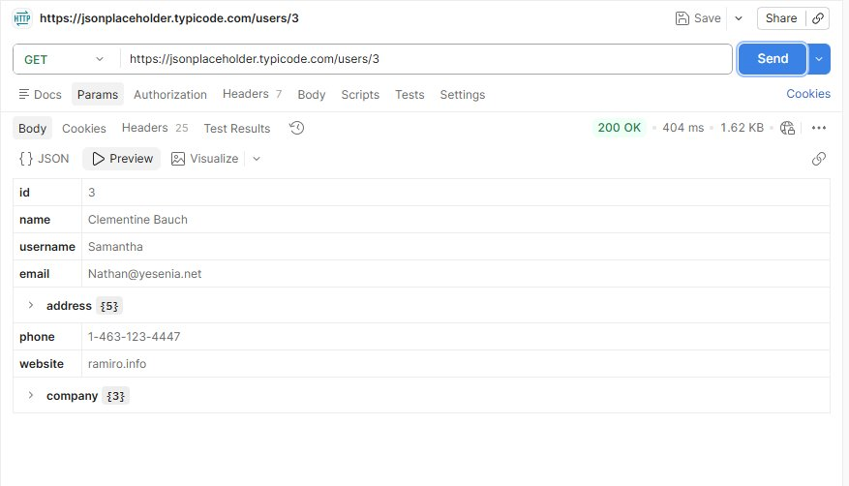
Screenshot 4a — Accessing user ID 3 (Clementine Bauch) with no authorization check
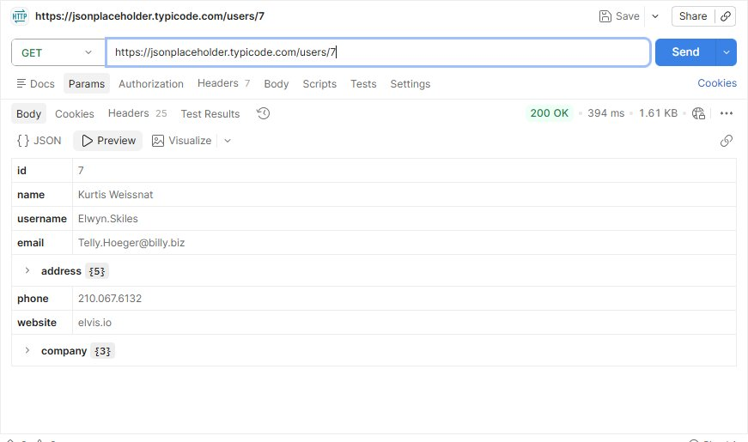
Screenshot 4b — Accessing user ID 7 (Kurtis Weissnat) just by changing the number in the URL
Finding 5 — Verbose Error Messages Exposing Internal API Structure [MEDIUM]
Endpoint | POST https://reqres.in/api/login
What I Did | Sent a POST login request without including the required API key header to see what error the API would give back.
What Happened | Instead of just saying '401 Unauthorized', the API returned: the exact header name it was expecting (x-api-key), a hint explaining admin vs user endpoint differences, a direct link to the auth documentation, an example cURL command showing how to authenticate, and 8 internal metadata fields.
Business Impact | This kind of detailed error response is essentially a roadmap for attackers. If I didn't know how to authenticate before, I definitely know now just from the error message. It tells me the header name, the endpoint structure, and where to find the docs. This falls under OWASP API7 — Security Misconfiguration.
How to Fix | Error responses to the client should only say something generic like '401 Unauthorized' or 'Access Denied'. Keep the detailed logging server-side only. Never include internal header names, architecture details, documentation URLs, or example commands in responses that go back to the requester.

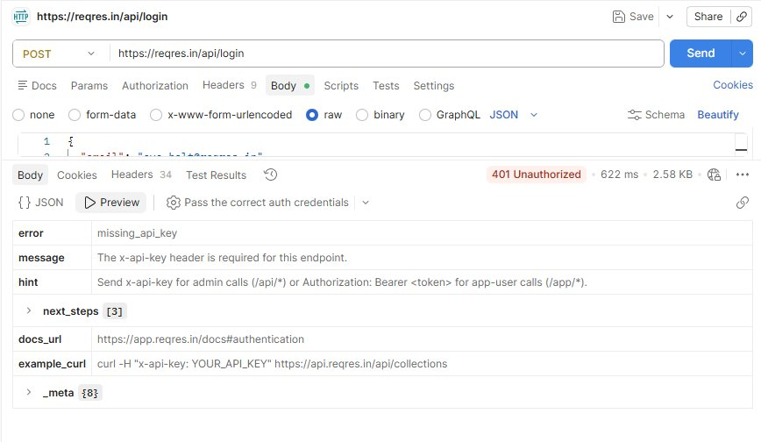
Screenshot 5 — ReqRes returning a 401 error that exposes the exact header name, hints, and documentation links
Finding 6 — Mass PII Exposure via Unauthenticated Endpoint [HIGH]
Endpoint | GET https://jsonplaceholder.typicode.com/comments
What I Did | Sent a GET request to the comments endpoint with absolutely no authentication or token.
What Happened | The API returned all 500 comment records in one response (155.17 KB). Every single record included a user's email address alongside their comment. No login, no API key, nothing — just 500 emails handed over in a single call.
Business Impact | Email addresses are PII (Personally Identifiable Information). A single unauthenticated API call returning 500 emails would be a reportable data breach under GDPR and similar laws. Attackers could harvest this data instantly and use it for phishing campaigns at scale.
How to Fix | Any endpoint that returns PII must require authentication. Emails should be masked or removed from responses unless the feature strictly needs them. Even for authenticated users, implement pagination to prevent someone from pulling all records in one shot.

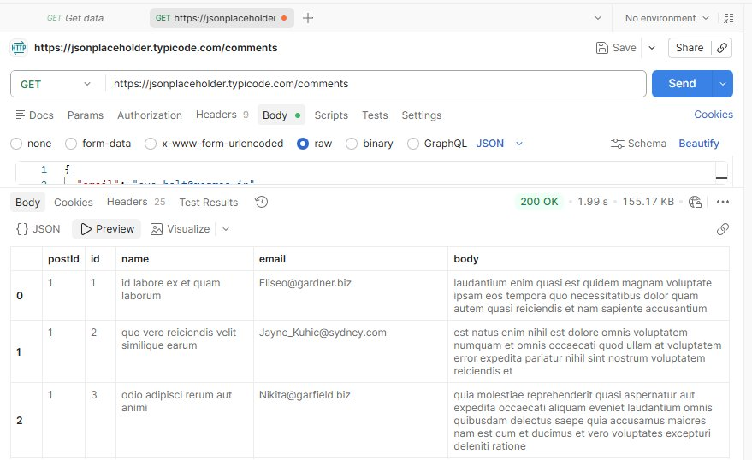
Screenshot 6a — /comments returning user email addresses with zero authentication (records 0-2)
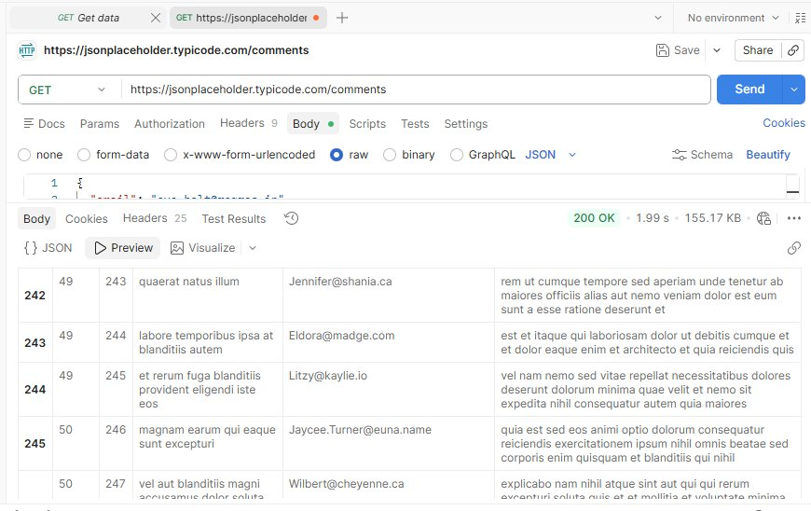
Screenshot 6b — Same endpoint exposing emails all the way through record 500 (155 KB of PII)

4. Risk Summary

# | Vulnerability | Endpoint | Severity
1 | No Authentication Required | GET /users | HIGH
2 | Excessive Data Exposure | GET /users/1 | MEDIUM
3 | No Rate Limiting | All endpoints | HIGH
4 | IDOR (Insecure Direct Object Reference) | GET /users/{id} | MEDIUM
5 | Verbose Error Messages | POST /login | MEDIUM
6 | Mass PII Exposure (Unauthenticated) | GET /comments | HIGH
5. Recommendations
Based on what I found during testing, here are the main things I'd recommend fixing:
- Require authentication on every endpoint that returns user data or any sensitive information.
- Only return fields that are actually needed for the feature — don't expose raw database rows.
- Add rate limiting on all endpoints. Start with 100 requests per minute per IP and adjust from there.
- Check object-level ownership before returning any resource to prevent IDOR attacks.
- Keep error messages generic for the client — detailed logs should stay server-side only.
- Mask or remove PII (emails, phone numbers) from any endpoint that doesn't strictly need them.
- Make sure HTTPS is enforced on all API traffic and use short-lived tokens with expiry.
- Do a regular security review against the OWASP API Security Top 10 checklist.
6. Conclusion
This task was a really good learning experience. Even though I was testing demo APIs — not real production systems — the vulnerabilities I found are exactly the same kinds of issues that show up in real API security audits. The fact that I could pull 500 email addresses or access any user's profile without logging in really shows how easy it is for these things to slip through when security isn't built in from the start.
The three High severity issues — no authentication, no rate limiting, and unprotected PII — would each on their own be serious enough to cause a data breach in a live system. Going through this analysis has made me much more aware of what to look for when reviewing APIs, and why security needs to be thought about at the design stage and not just added on later.

Note: All testing on publicly available demo APIs only. No real user data accessed or stored. No unauthorized systems touched. Submitted as part of Future Interns Cyber Security Internship - Task 3.

